Adaptive Spreading Factor (SF) Selection
Table Of Contents
1. Objective 2
2. Background and Motivation 2
3. Simulation Setup 2
3.1 LoRa PHY Simulation Platform 2
3.2 Parameter Definitions 3
3.3 PER Metric 3
4. Fixed-SF Baseline Curves 3
5. Adaptive SF Strategy — Code Explanation (MATLAB Implementation) 3
5.1 Initialization and Common Simulation Settings 3
5.2 Fixed-SF Baseline PER Curves 4
5.3 PER Curve Smoothing (Threshold Stability) 5
5.4 Reliability Threshold and Automatic Switching Points 5
5.5 Adaptive PER Construction and SF Selection 5
5.6 Visualization 6
5.6.1 Fixed SF vs Adaptive SF (PER vs SNR) 6
5.6.2 Selected SF vs SNR 6
5.7 Fixed-SF PER Simulation Function (run_one_sf) 6
5.7.1 Packetization and Symbol Generation 6
5.7.2 Chirp Generation 6
5.7.3 AWGN Injection and Non-Coherent Detection 7
5.7.4 PER Computation 7
6. Output and Visualization 7
6.1 Fixed SF Performance Behaviour 7
6.2 Automatic Threshold Detection 8
6.3 Adaptive PER Curve Interpretation 9
6.4 Selected SF Behaviour 9
6.5 Performance Gains Over Fixed SF 10
6.6 Observed Small PER Fluctuations 10
6.7 Conclusion of Adaptive SF Evaluation 10
7. Discussion 11
8. Limitations and Future Extensions 11
9. Conclusion 11

1. Objective
The objective of the adaptive spreading factor (SF) module is to improve link reliability under varying channel quality while avoiding unnecessary reduction in data rate. Instead of operating with a fixed SF (e.g., $SF7$ or $SF12$ for all conditions), the transmitter selects an appropriate SF based on the estimated channel quality represented by the signal-to-noise ratio (SNR). The approach targets a predefined reliability requirement expressed as a packet error rate (PER) threshold.

2. Background and Motivation
LoRa systems support multiple SF configurations. A higher SF increases symbol duration and processing gain, improving robustness against noise and enabling successful reception at lower SNR values, but at the cost of lower data rate and longer time-on-air. Conversely, a lower SF improves throughput but requires a higher SNR for reliable reception. Therefore, an adaptive SF strategy provides a practical mechanism to balance reliability and efficiency by selecting the lowest SF that still satisfies the reliability requirement.

3. Simulation Setup
The adaptive SF module is implemented and evaluated using a MATLAB-based PHY-layer LoRa simulation. The simulation generates PER vs. SNR curves for multiple fixed SF values and then constructs an adaptive strategy based on these results.

3.1 LoRa PHY Simulation Platform
The adaptive spreading factor strategy was implemented and evaluated using a MATLAB-based LoRa physical layer simulator derived from the LoRaBERMatlab framework. The simulator models the LoRa chirp spread spectrum modulation, additive white Gaussian noise (AWGN) channel conditions, and non-coherent FFT-based symbol detection.
The LoRaBERMatlab environment provides symbol-level Monte Carlo simulation capability for estimating BER, SER, and PER performance across a configurable SNR range. In this work, the framework was adapted to focus on packet error rate (PER) evaluation under non-coherent detection, which aligns with system-level reliability analysis.
The simulation structure includes:
- Random symbol generation
- LoRa chirp modulation
- AWGN channel model
- FFT-based non-coherent demodulation
- Packet-level error evaluation
The simulator was modified to enable multi-SF evaluation (SF7, SF9, SF12) under identical channel conditions, allowing consistent comparison and construction of the adaptive SF mechanism.

3.2 Parameter Definitions
- SNR range: Discrete set of SNR points, typically $SNR∈[-30,30]$ dB with 1 dB step.
- Spreading factors tested: $SF∈\{7,9,12\}.$
- Packet structure: Packets consist $N_{m}$​ symbols per packet, and the simulation transmits $N_{s}$ symbols per run. The number of packets is $N=Ns​/Nm​$ .
- Channel model: AWGN (additive white Gaussian noise) for baseline evaluation.

3.3 PER Metric
PER is defined as the fraction of packets that contain at least one symbol error:
$$PER=\frac{packets with ≥1 error}{total packets}$$
This metric is chosen because the adaptive SF decision is intended to ensure packet-level reliability, which is the relevant performance indicator for higher-layer communication protocols.

4. Fixed-SF Baseline Curves
The first step of the method is to generate fixed-SF performance curves:
- For a given SF, random symbols are generated and modulated to a LoRa chirp signal.
- AWGN is added according to each SNR point.
- The receiver performs non-coherent detection via FFT-based peak selection.
- Symbol decisions are grouped into packets and PER is computed.
- The process is repeated for each SF value to obtain:
$${PER}_{SF7}\left(SNR\right)$$
$${PER}_{SF9}\left(SNR\right)$$
$${PER}_{SF12}\left(SNR\right)$$
These curves provide the empirical relationship between channel quality and packet reliability for each SF configuration.

5. Adaptive SF Strategy — Code Explanation (MATLAB Implementation)
This section explains the MATLAB implementation of the SNR-based adaptive spreading factor (SF) selection used to construct an adaptive PER curve from fixed-SF simulation results.
The fixed-SF PER curves used for adaptive threshold extraction were obtained using the LoRaBERMatlab-based simulation framework described in Chapter 3.

5.1 Initialization and Common Simulation Settings
- 1. clear; clc;
- 2. Ns = 3e4;
- 3. Nm = 1e2;
- 4. BW = 125e3;
- 5. SNR = -30:30;
- clear; clc; resets the MATLAB workspace and command window to avoid using stale variables.
- Ns is the total number of transmitted symbols used in the Monte-Carlo simulation.
- Nm is the number of symbols per packet; therefore the number of packets is (N = Ns/Nm).
- BW is the LoRa signal bandwidth.
- SNR is the discrete SNR axis (61 points) used for evaluation and plotting.

5.2 Fixed-SF Baseline PER Curves
1. [PER_SF7, SNR] = run_one_sf(7, Ns, Nm, BW, SNR);
2. [PER_SF9, ~ ] = run_one_sf(9, Ns, Nm, BW, SNR);
3. [PER_SF12, ~ ] = run_one_sf(12, Ns, Nm, BW, SNR);
The function run_one_sf() is executed three times to obtain baseline PER curves for:
- SF7 → PER_SF7(SNR)
- SF9 → PER_SF9(SNR)
- SF12 → PER_SF12(SNR)
All three calls use the same SNR vector and identical simulation parameters, ensuring a valid point-by-point comparison across SFs.
The tilde ~ is used to ignore the second returned output (the SNR vector), because the same SNR vector is already captured from the first call and reused.

5.3 PER Curve Smoothing (Threshold Stability)
1. s7 = smoothdata (PER_SF7, ‘gaussian', 5);
2. s9 = smoothdata (PER_SF9, ‘gaussian', 5);
3. s12 = smoothdata (PER_SF12, 'gaussian', 5);
The PER points are generated using random noise realizations; therefore, near the transition region the measured PER may show small fluctuations. Smoothing is applied to stabilize threshold extraction:
- Gaussian smoothing with window length 5 produces smoothed curves s7, s9, s12.
- Smoothing is only used for detecting the transition SNR points, not for the final PER plot (the final plot still uses raw PER arrays).

5.4 Reliability Threshold and Automatic Switching Points
1. thresh = 0.2;
2. SNR_SF7_ok = SNR(find(s7 < thresh, 1, 'first'));
3. SNR_SF9_ok = SNR(find(s9 < thresh, 1, 'first'));
A target reliability requirement is defined as:
$$PER≤τ$$
where thresh = 0.2 corresponds to $τ=0.2$

For each SF, the code finds the first SNR value (lowest SNR) at which the smoothed PER curve goes below the target:
- SNR_SF9_ok: the first SNR where SF9 becomes “acceptable” (PER < 0.2)
- SNR_SF7_ok: the first SNR where SF7 becomes “acceptable” (PER < 0.2)
These two points are then used as transition thresholds:
1. T1 = SNR_SF9_ok; % transition SF12 -> SF9
2. T2 = SNR_SF7_ok; % transition SF9 -> SF7
Interpretation:
- Below T1, SF9 does not meet the PER target → use SF12.
- Between T1 and T2, SF9 meets the target but SF7 does not → use SF9.
- Above T2, SF7 meets the target → use SF7.
This enforces the design rule: use the smallest SF that satisfies the PER constraint, improving throughput while maintaining reliability.

5.5 Adaptive PER Construction and SF Selection
1. PER_adapt = zeros (size (SNR));
2. SF_sel = zeros (size (SNR))
3. for i = 1: numel (SNR)
4. if SNR(i) < T1
5. PER_adapt(i) = PER_SF12(i); SF_sel(i) = 12;
6. elseif SNR(i) < T2
7. PER_adapt(i) = PER_SF9(i); SF_sel(i) = 9;
8. else
9. PER_adapt(i) = PER_SF7(i); SF_sel(i) = 7;
10. end
11. end
This loop generates:
- PER_adapt(i): the adaptive PER value at each SNR point
- SF_sel(i): the selected SF at each SNR point
The adaptive curve is not re-simulated from scratch; instead it is constructed by selecting the corresponding PER sample from the fixed-SF curves according to the switching rule.
Formally, for each discrete SNR point:
$$SF\left(SNR\right)=\left\{\begin{aligned}{PER}_{SF12}\left({SNR}_{i}\right), \\ {PER}_{SF9}\left({SNR}_{i}\right), \\ {PER}_{SF7}\left({SNR}_{i}\right)\end{aligned}\right. \begin{matrix}{SNR}_{i}<T_{1} \\ T_{1}≤{SNR}_{i}<T_{2} \\ {SNR}_{i}≥T_{2}\end{matrix}$$

5.6 Visualization

5.6.1 Fixed SF vs Adaptive SF (PER vs SNR)
1. plot (SNR, PER_SF7, ‘-o', ...);
2. plot (SNR, PER_SF9, ‘-s', ...);
3. plot (SNR, PER_SF12, '-d', ...);
4. plot (SNR, PER_adapt,'-k', 'LineWidth', 2, ...);
5. xline(T1,'--r',...);
6. xline(T2,'--b',...);
This plot compares the three fixed-SF baseline curves and the constructed adaptive curve on the same SNR axis. The vertical lines mark the switching thresholds T1 and T2.

5.6.2 Selected SF vs SNR
1. figure; stairs (SNR, SF_sel, 'LineWidth', 2);
This staircase plot explicitly shows which SF is used at each SNR. It provides a direct visual confirmation that the adaptive algorithm switches:
- SF12 → SF9 at T1
- SF9 → SF7 at T2

5.7 Fixed-SF PER Simulation Function (run_one_sf)
1. function [PER_AWGN, SNR] = run_one_sf(SF, Ns, Nm, BW, SNR)
This function performs the PHY simulation for one SF value under AWGN.

5.7.1 Packetization and Symbol Generation
1. N = Ns/Nm;
2. M = 2^SF;
3. x = randi(M,1, Ns) - 1;
- $M=2SF$ is the symbol alphabet size.
- x is a random symbol stream in [0, M-1].
- Total packets are (N = Ns/Nm).

5.7.2 Chirp Generation
1. upChirp = loramod(x, SF, BW, BW);
2. dnChirp = loramod(0, SF, BW, BW, -1);
3. signal = upChirp .* repmat (dnChirp, length(upChirp)/length(dnChirp), 1);
loramod () generates the LoRa chirp-modulated waveform.
The multiplication with a repeated downchirp corresponds to the standard LoRa dechirping step before FFT detection.

5.7.3 AWGN Injection and Non-Coherent Detection
1. sigma = 1./ 10.^(SNR(CtrSNR)./20);
2. n = sigma/sqrt (2). * (randn(M*Ns,1) + 1j*randn(M*Ns,1));
3. Rx1 = signal + n;
4.
5. [~, idx] = max (fft (reshape (Rx1, M, Ns)));
6. ynCoh1 = idx - 1;
Noise is generated as complex Gaussian (I/Q) with variance determined by SNR.
The receiver reshapes received samples into M × Ns, performs FFT, and selects the maximum bin index as the detected symbol (non-coherent detection).

5.7.4 PER Computation
1. PER_AWGN(CtrSNR) = sum(sum(abs(reshape(x,N,Nm) - reshape(ynCoh1,N,Nm)), 2) > 0) / N;
Symbols are reshaped into packets of length Nm.
A packet is counted as erroneous if any symbol differs.
PER is the fraction of erroneous packets.

6. Output and Visualization
This section presents the performance evaluation of the proposed SNR-based Adaptive Spreading Factor (SF) mechanism and compares it against fixed-SF configurations (SF7, SF9, SF12). The analysis is based on packet error rate (PER) under AWGN channel conditions.

6.1 Fixed SF Performance Behaviour
From the PER vs. SNR curves:
- SF12 operates reliably at very low SNR values (around −22 dB region).
- SF9 becomes reliable at moderate SNR levels (around −13 dB region).
- SF7 requires higher SNR values (around −8 dB region) to achieve low PER.
This behaviour is expected due to LoRa modulation characteristics:
- Higher SF → longer symbol duration → higher processing gain → better noise robustness.
- Lower SF → shorter symbol duration → higher data rate but lower noise immunity.
Thus, fixed-SF operation creates a trade-off:
SF | Reliability at Low SNR | Throughput | Energy per Bit
SF12 | High | Low | High
SF9 | Medium | Medium | Medium
SF7 | Low (at low SNR) | High | Low
Using a single fixed SF across all SNR regions is therefore inefficient.

6.2 Automatic Threshold Detection
A PER constraint of:
$$PER<0.2$$
was selected as the target reliability requirement.
From the smoothed PER curves, two switching thresholds were automatically extracted:
- $T1 ≈ -13 dB$
Transition from SF12 to SF9.
- $T2 ≈ -7 dB$
Transition from SF9 to SF7.
These thresholds correspond to the first SNR points where the next lower SF satisfies the PER requirement.
This ensures that:
- The system never switches to a lower SF before it becomes reliable.
- The smallest possible SF that satisfies reliability is always selected.
As shown in Figure 6.1, the adaptive scheme follows SF12 in the low-SNR region, transitions to SF9 at T1 ≈ −13 dB, and finally switches to SF7 at T2 ≈ −7 dB.
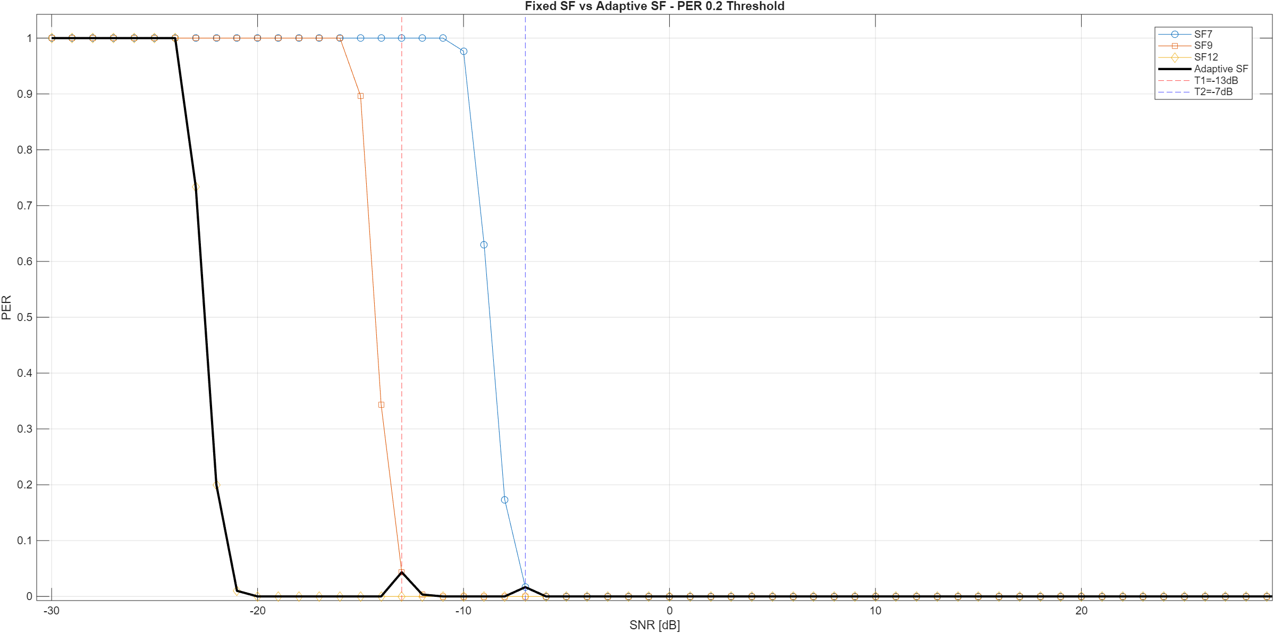
Figure 6.1: – PER vs SNR for Fixed and Adaptive SF (PER Threshold = 0.2)

6.3 Adaptive PER Curve Interpretation
The adaptive PER curve (black curve in the first figure) is constructed by selecting:
- SF12 when SNR < T1
- SF9 when T1 ≤ SNR < T2
- SF7 when SNR ≥ T2
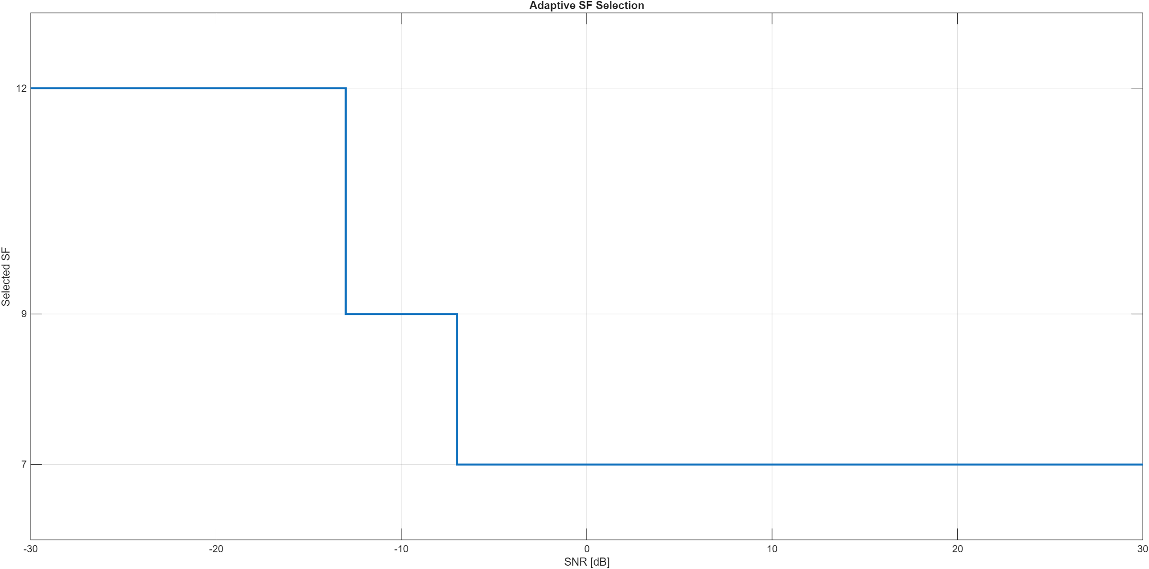
Figure 6.2: Adaptive SF Selection as a Function of SNR
Figure 6.2 illustrates the discrete switching behaviour of the adaptive algorithm across the SNR range.
The resulting behaviour shows:
- At very low SNR, adaptive performance matches SF12.
- In the mid-SNR region, performance transitions smoothly to SF9.
- At higher SNR values, adaptive performance follows SF7.
The adaptive curve therefore represents the envelope of reliable performance while maximizing efficiency.

6.4 Selected SF Behaviour
The second figure (Adaptive SF Selection) clearly shows the switching logic:
- $SNR < -13 dB → SF12$
- $-13 dB ≤ SNR < -7 dB → SF9$
- $SNR ≥ -7 dB → SF7$
The staircase structure confirms correct implementation of threshold-based switching.
This behaviour reflects practical LoRa adaptive data rate logic, but here it is derived directly from PHY-layer performance constraints.

6.5 Performance Gains Over Fixed SF
Compared to fixed-SF operation:

Compared to Fixed SF12
- Adaptive SF achieves identical reliability at low SNR.
- At higher SNR, it significantly increases throughput by switching to lower SF.

Compared to Fixed SF7
- Adaptive SF avoids the high PER region at low SNR.
- It prevents packet loss by switching to more robust SFs.
Thus, adaptive SF achieves:
- Reliability of the most robust SF when needed.
- Throughput efficiency of lower SF when channel conditions allow.

6.6 Observed Small PER Fluctuations
Minor spikes in the adaptive curve around switching boundaries are due to:
- Monte-Carlo randomness in PER estimation.
- Discrete SNR sampling (1 dB resolution).
- Packet-level error counting (binary packet success/failure).
These fluctuations do not indicate instability in the adaptive logic.

Increasing Ns (number of symbols) would further smooth the curves but at the cost of simulation time.

6.7 Conclusion of Adaptive SF Evaluation
The proposed adaptive SF mechanism successfully:
- Maintains a predefined PER reliability constraint.
- Automatically determines switching thresholds from simulation data.
- Maximizes efficiency by selecting the minimum required SF.
- Provides a clear improvement over fixed-SF configuration.
The results demonstrate that SNR-based adaptive spreading factor selection is an effective method for balancing reliability and spectral efficiency in LoRa systems.

7. Discussion
The adaptive SF method provides a structured way to improve robustness at low SNR while maximizing efficiency at higher SNR. At very low SNR values, SF12 is selected to maintain packet delivery. As SNR improves, the method transitions to SF9 and finally to SF7, reducing time-on-air and increasing throughput.
Minor discontinuities in the adaptive PER curve can occur near switching thresholds due to finite Monte-Carlo sampling and discrete SNR resolution. Increasing the number of simulated symbols or applying smoothing reduces such artifacts.

8. Limitations and Future Extensions
The presented adaptive method is SNR-based and evaluated under AWGN conditions. Extensions may include:
- Interference-aware selection using SINR instead of SNR
- Joint adaptation of SF and coding rate (CR)
- Time-varying SNR models and mobility-aware adaptation
- Network-level evaluation including collisions and LoRaWAN ADR benchmarking

9. Conclusion
This work implemented an SNR-based adaptive SF selection mechanism in a MATLAB LoRa PHY simulation framework. The method uses fixed-SF PER curves to derive switching thresholds that satisfy a target PER, then constructs an adaptive PER curve reflecting dynamic SF selection. The results demonstrate that adaptive SF can maintain reliability under poor channel conditions while improving efficiency when channel quality allows lower SF operation.

